USOSweb – registrations
ver. 1.0

Registrations for classes takes place at web.usos.pwr.edu.pl (USOSWeb). The USOSweb service is integrated with the main database of the USOS. Data from the USOS system are visible in the USOSweb (and vice versa) after data synchronization, which takes place several times a day.
Planned registrations are visible in the NEWS menu in the REGISTRATION CALENDAR tabs.
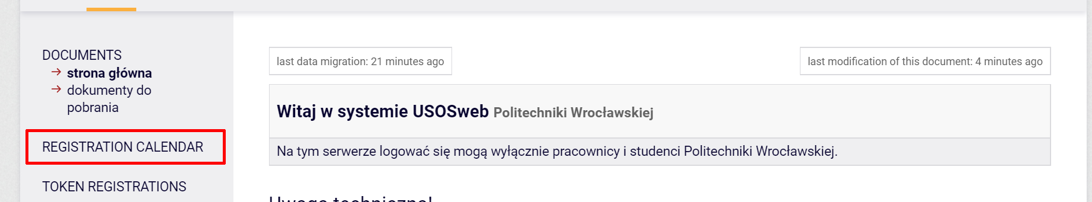
Figure 1
Access to registration is limited by the adding a person to a specific registration. This operation is performed by the university administration. Therefore, before starting date, it is recommended to check that you have access to the correct registration. This is especially important for registration, where "first come, first served" counts.
In the NEWS -> REGISTRATION CALENDAR tab, after selecting the unit organizing the registration, the registration details will be displayed. The √ icon means that when registration starts, you will be able to sign up for the offered activities. It may happen you are not entitled to the registration. In this case it must be reported to the unit that organizes the registration to activate the access. After adding a student to registration on the USOSadm side, data synchronization is necessary.
If you are entitled to participate in registration, after logging in to the USOSweb website, go to the STUDENT menu tab and select the Registration module (Fig. 2).
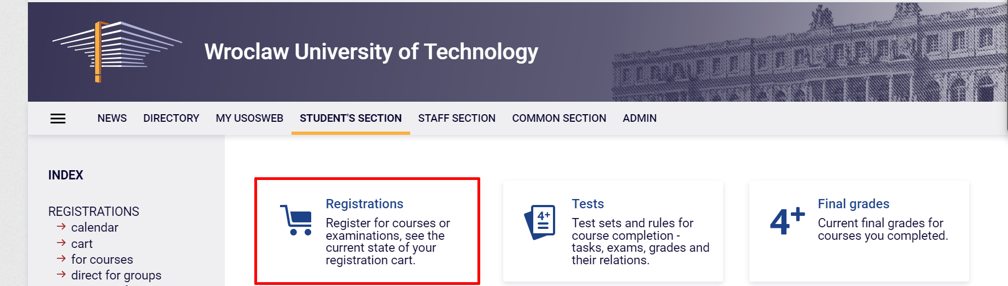
Figure 2
Select Registrations for courses (Fig. 5) and go to the Registration Calendar page (Fig. 3).
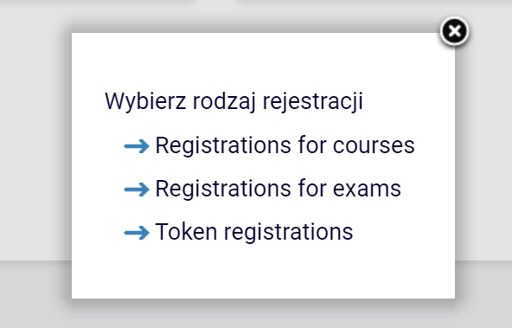
Figure 3
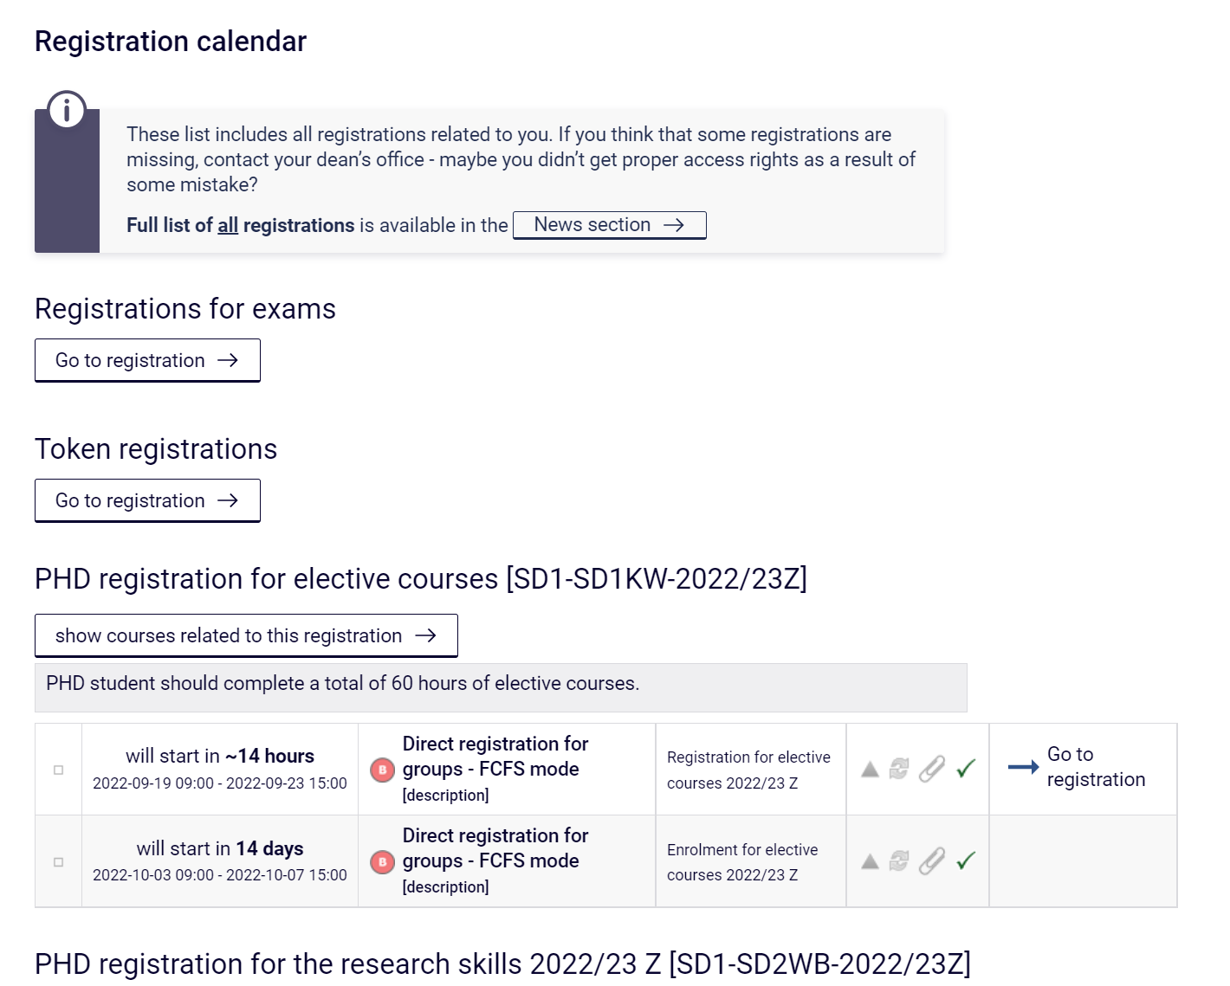
Figure 4
In this section you will see all registrations that you have access to and you can take part in several of them. Please read the description of the registration carefully, it will inform you about details.
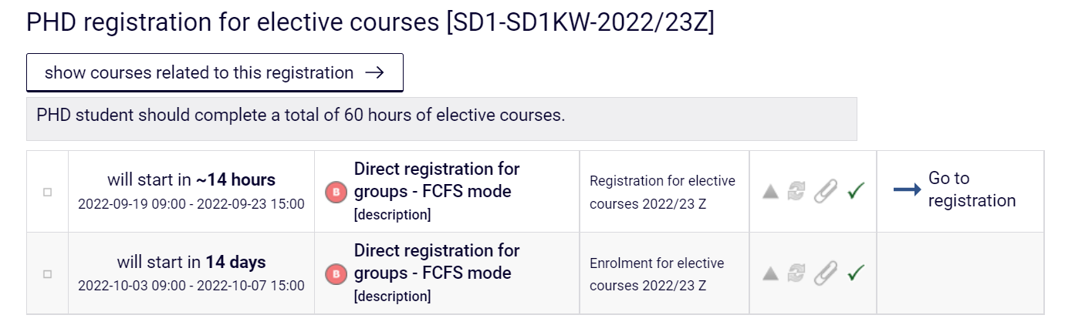
Figure 5
If You select Show courser related to this registration, a screen with a list of items to choose from will open.
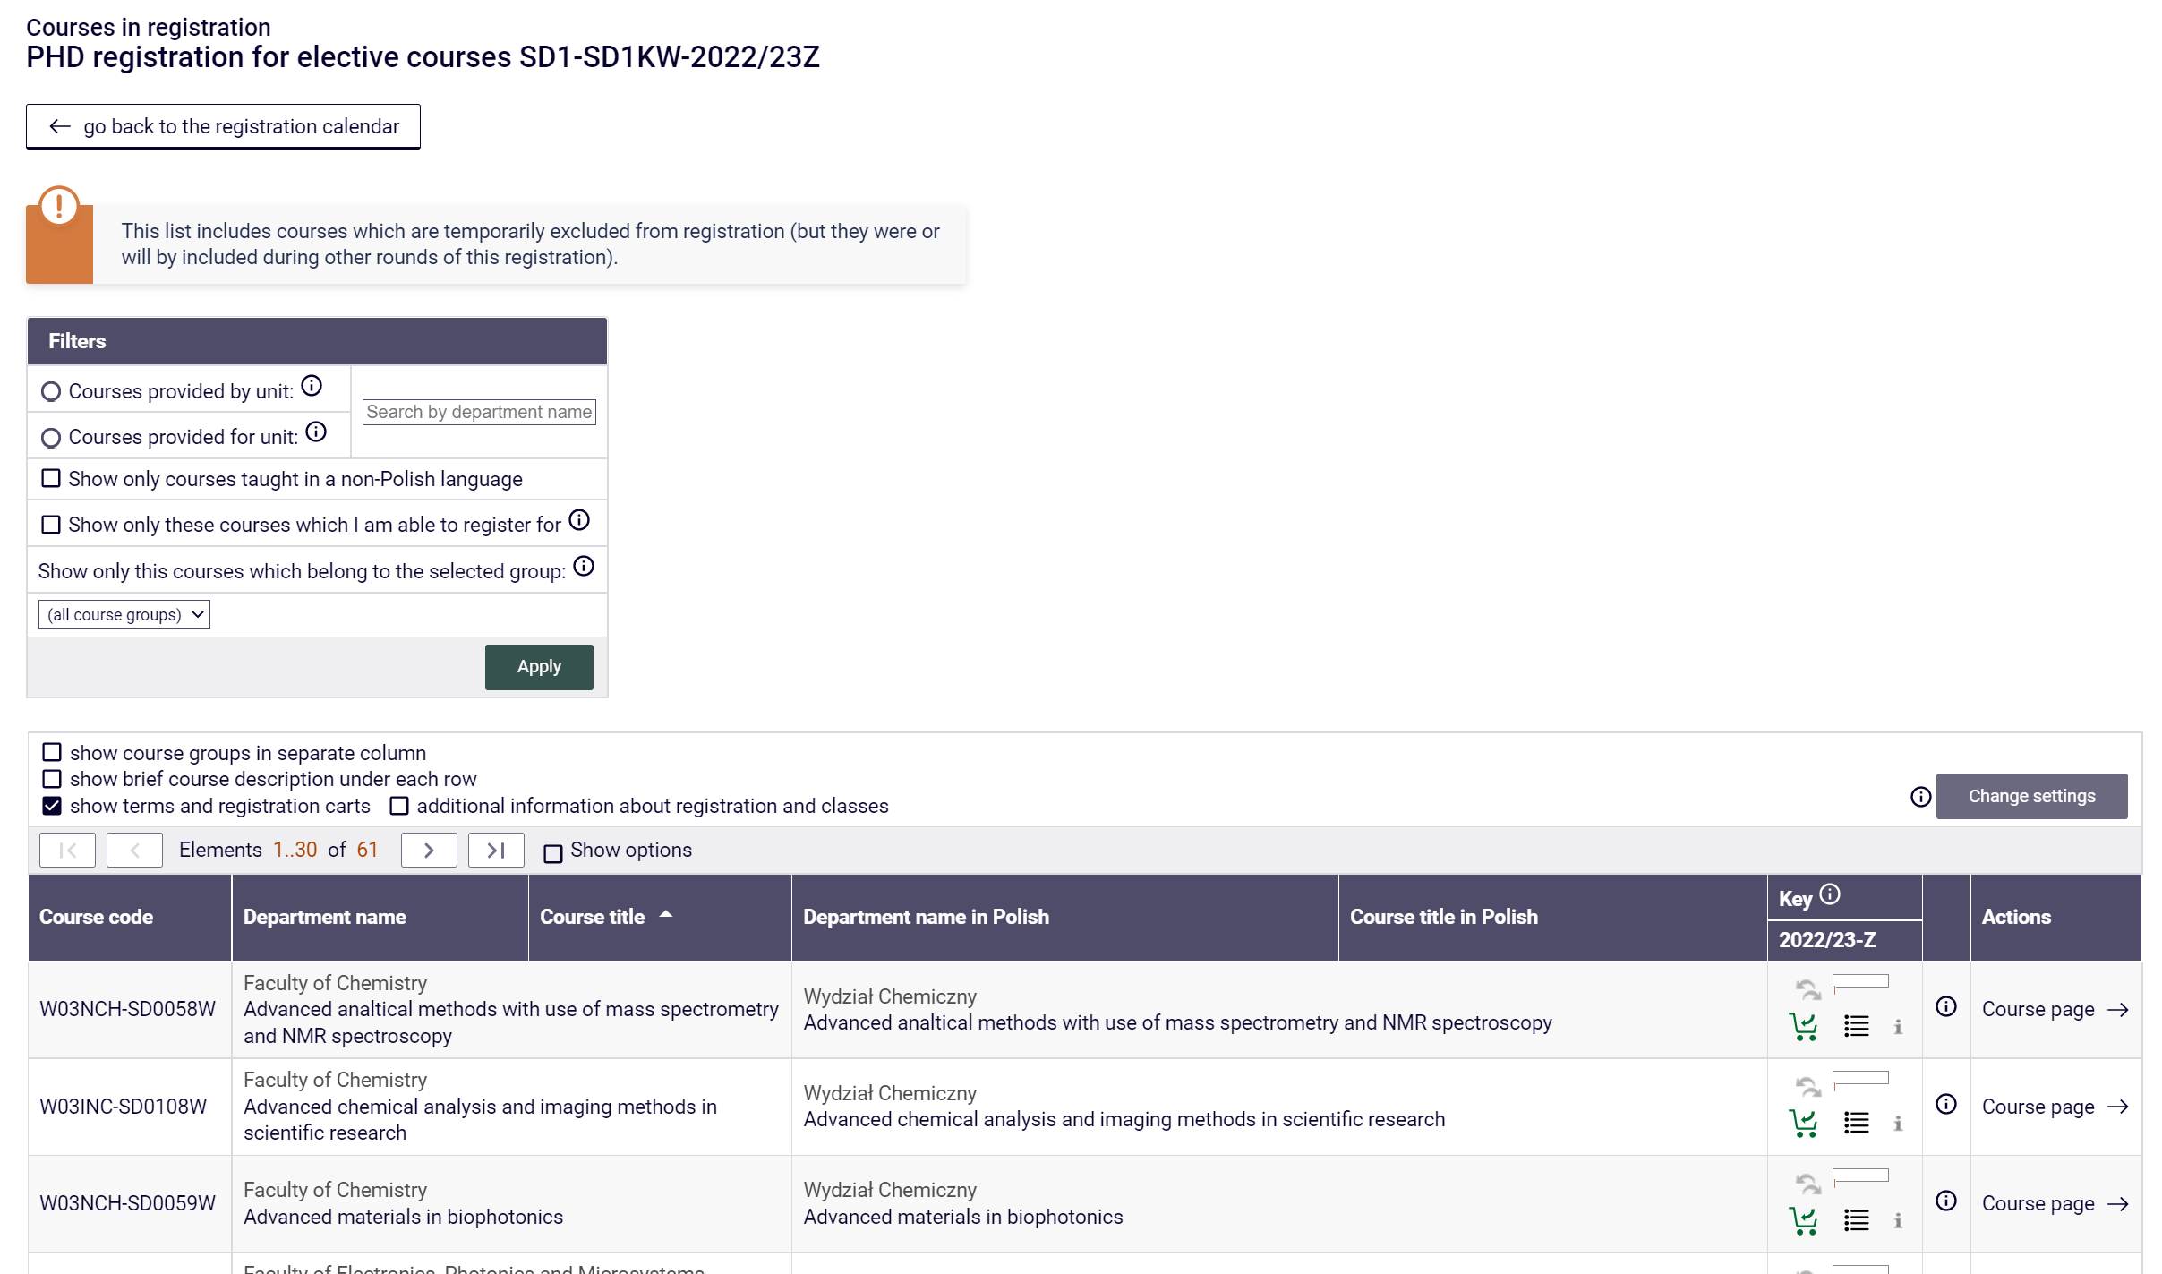
Figure 6

By clicking on the Course page link, we go to the page with full information about the subject, such as: the teacher, the forms of classes, and most of all the timetable for a given subject, thanks to which you will be able to plan your timetable so that classes they did not collide with each other (Fig. 7).

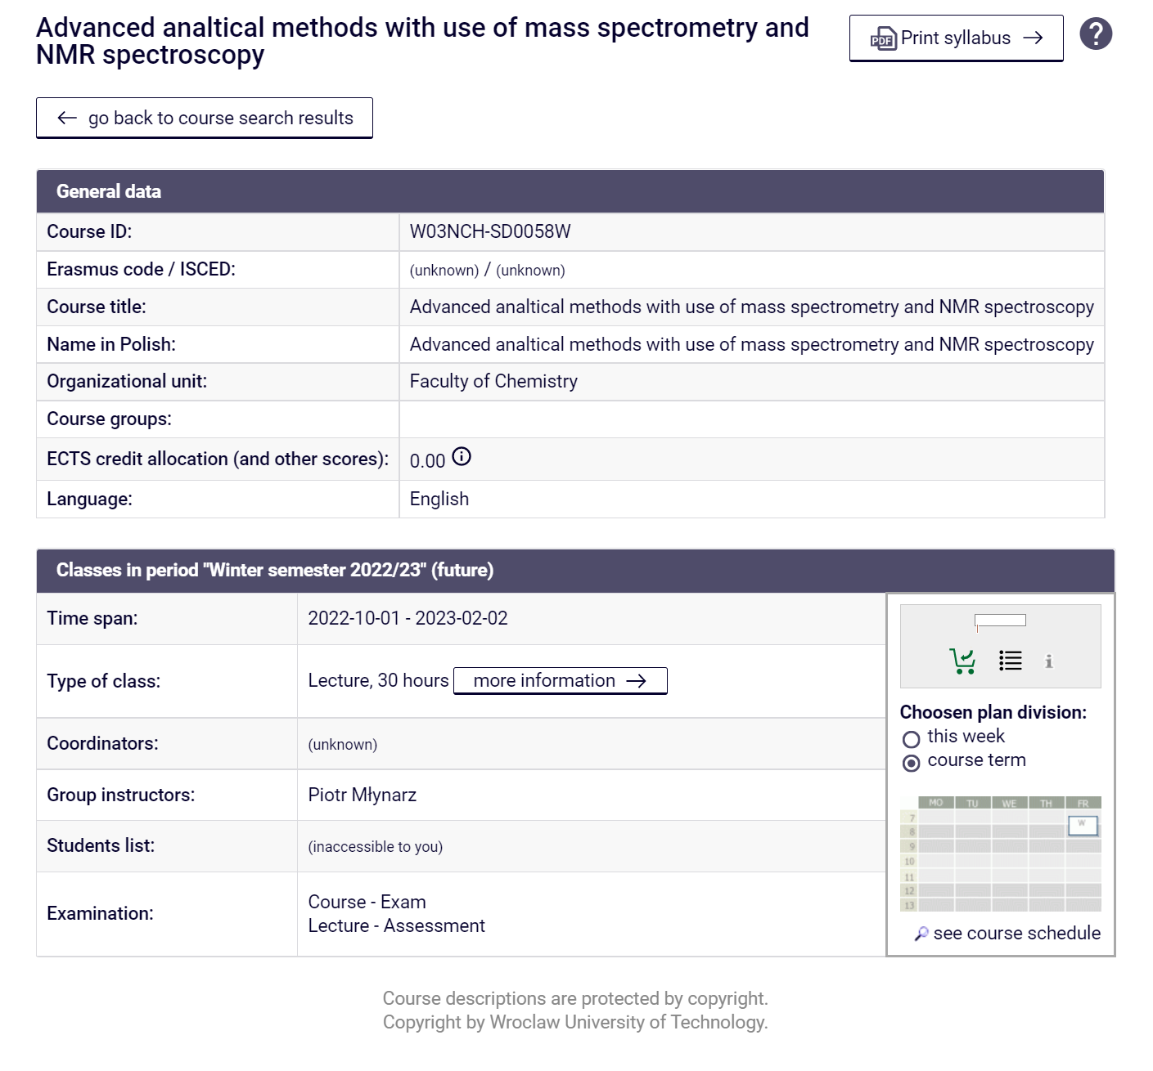
Figure 7
On the Registration Calendar page (Fig. 8), we also have information about:
- term (time to the start of the registration round, and during the registration round, the time to its end),
- registration mode (e.g. the icon means that it is a direct registration for a subject and a class group, with the variant "first come, first served"),
- number of turns (registration may or may not be divided into rounds, the description of the registration shows the rules for participation in individual rounds),
- additional registration attributes, e.g .:
  - means that it is a dedicated registration, i.e. that some or all class groups are intended for students of specific programs/stages or a specific gender,
  - means that registered students can exchange places during this round,
  - informs us that we are to register for 5 subjects in this registration,
  - means that the student, when registering for the course, must declare the program to which he / she wants to connect it,
  - means that the student has access / rights to participate in this registration.

Figure 8

By clicking the Go to registration link (Fig. 8), we go to the registration window, where we can see all the registration-related items (Fig. 9).
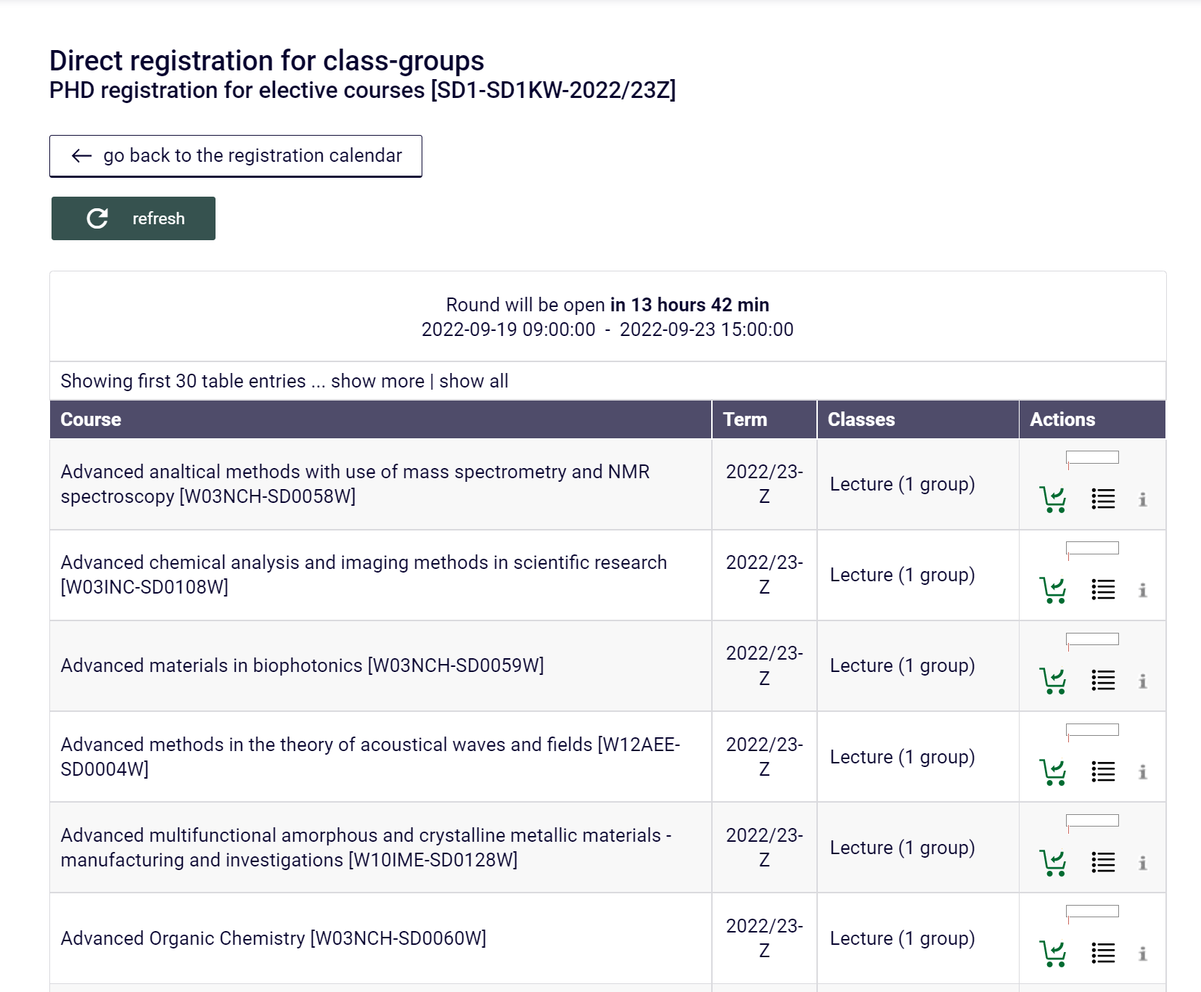
Figure 9

To register, next to the item in the Actions column, click the green basket icon (Fig. 10). This redirect to the page of a specific subject, where, if the subject classes have more than one group, the group selection will appear. Select a class group and then click the Register button (Fig. 10).
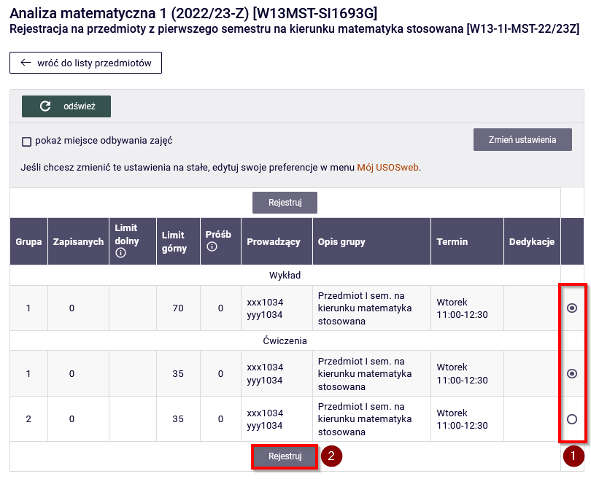
Figure 10
Registration for the course will be confirmed with the message shown in Fig. 11 and clicking the refresh button will update the information about the number of enrolled students.
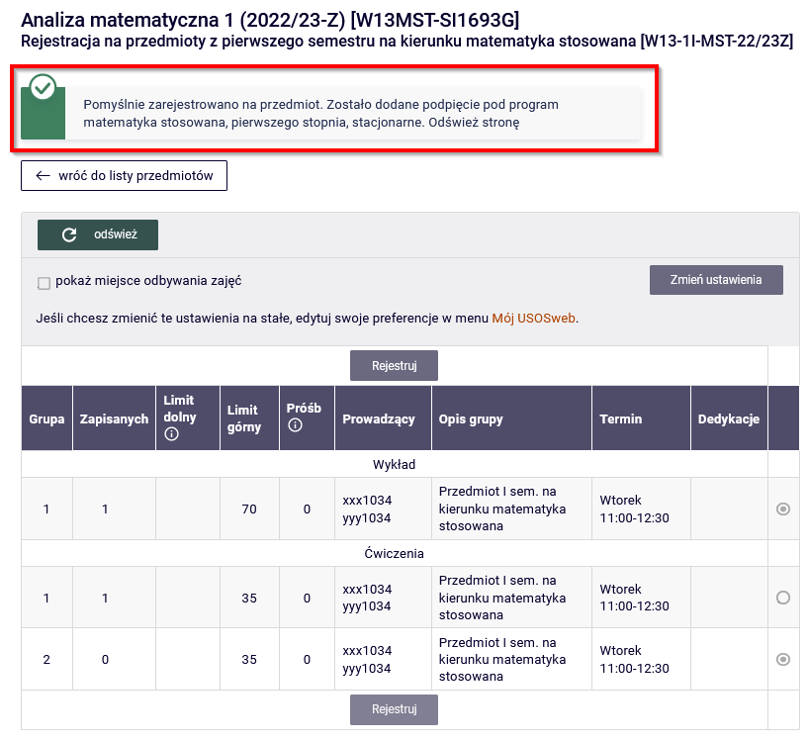
Figure 11

Registration for the course will be impossible when the limit of places is exhausted. Information about the current filling level of all groups is shown in the bar in the Actions column. Hovering the mouse over the bar displays information about the number of registered people and the limit of places. Deregister is possible with the click on the red basket icon next to the wrongly selected item. Clicking on the icon will take us to a page with detailed information about the number of registered people and the limit of places in each class group.
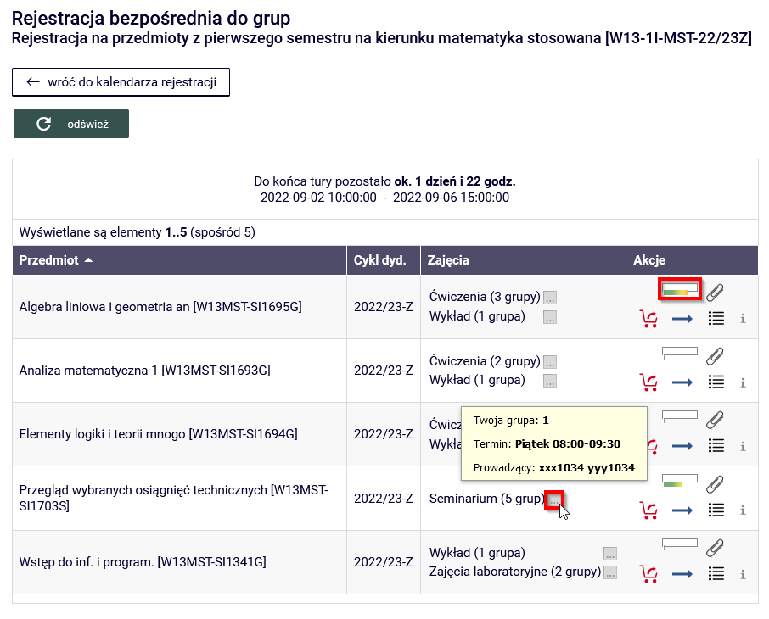
Figure 12

If registration allows an exchange during the turn, registered students can exchange places. To do this, click on the icon , then select the group or groups that we are interested and confirm (Fig. 13). When another student also requests an exchange or unsubscribes from the subject, the system will replace the group. Your application will be active until the end of this round of registration.
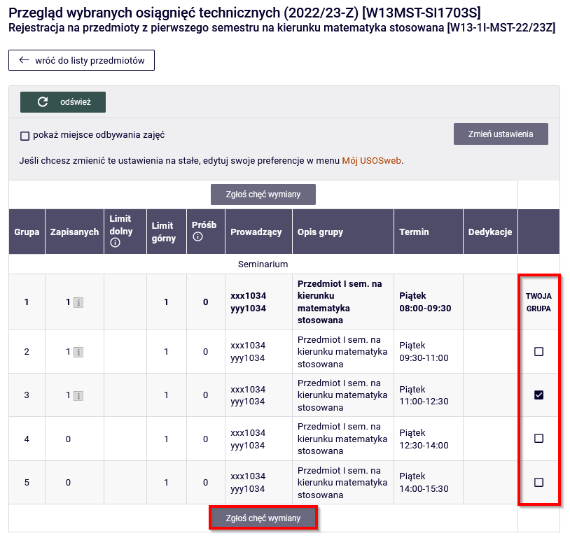
Figure 13

